# Dashboard:
Our team has used Microsoft PowerBI to create a dashboard, which provides insights throughout the data.
Steps In Dashboard Creation:
- Requirement Gathering/ Business Requirements
- Data Walkthrough
- Data Connection
- Data Cleaning / Quality Check
- Data Modeling
- Data Processing
- DAX Calculations
- Dashboard Lay outing
- Charts Development and Formatting
- Dashboard / Report Development
- Insights Generation

BUSINESS REQUIREMENT
- In today’s digital music era, understanding listening patterns is crucial for both users and streaming platforms. This analysis focuses on Spotify Albums Data, providing insights into user engagement with albums over time.

- Dashboard Overview
This Overview dashboard has three panels:
- Albums (Left)
- Artists (Middle)
- Tracks (Right)
A platform slicer at the top right allows filtering by device (Android, Mac, Windows), helpful for user behaviour segmentation.

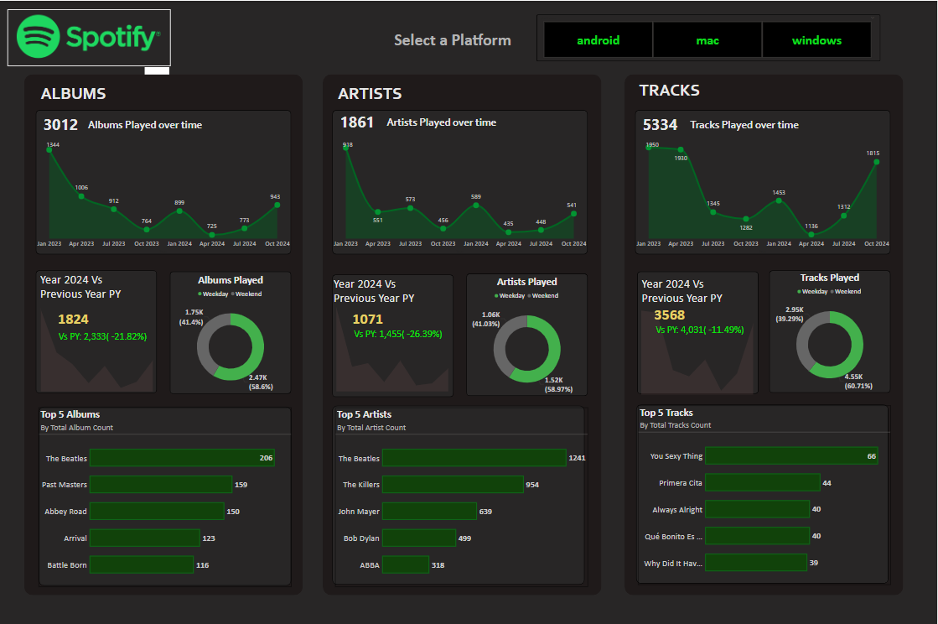

ALBUMS
- Total Albums Played Over Time – Track how album listening trends change over months and years.
Number of Albums Listened by Year – Identify annual listening habits and volume (Find the Min and Max Albums in the view).
- Albums Played on Weekday & Weekend – Identify the Pattern of music listening on weekdays and weekends.
Top 5 Albums – Identify the most played albums based on listening frequency.
- Latest Year vs Previous Year Analysis – Compare album consumption between the latest and previous years, including:
  - LY (Latest Year) vs PY (Previous Year) Trends
  - YoY (Year-over-Year) Growth Analysis.

ARTITST
- Total Artists Played Over Time – Track how artist listening trends evolve across months and years.
- Number of Artists Listened by Year – Identify annual listening habits and artist diversity. (Find the Min and Max Artists in the view).
- Artists Played on Weekday & Weekend – Identify the Pattern of music listening on weekdays and weekends.
Top 5 Artists – Identify the most played artists based on listening frequency.
- Latest Year vs Previous Year Analysis – Compare artist engagement between the latest and previous years, including:
  - LY (Latest Year) vs PY (Previous Year) Trends
  - YoY (Year-over-Year) Growth Analysis

TRACKS
- Total Tracks Played Over Time – Monitor how track listening trends change across months and years
- Number of Tracks Listened by Year – Identify annual listening habits and track diversity. (Find the Min and Max Tracks in the view).
- Tracks Played on Weekday & Weekend – Identify the Pattern of music listening on weekdays and weekends.
- Top 5 Tracks – Identify the most played tracks based on listening frequency.
- Latest Year vs Previous Year Analysis – Compare track engagement between the latest and previous years, including:
  - LY (Latest Year) vs PY (Previous Year) Trends
  - YoY (Year-over-Year) Growth Analysis

- LISTENING PATTERNS

Listening Hours Analysis – Identify peak listening times using a Heat Map that visualizes patterns across hours and days with color intensity.
Average Listening Time (min) vs Track Frequency – Use a Scatter Plot with Quadrant Analysis to categorize tracks based on:
  - High Frequency & High Listening Time – Most engaging tracks.
  - Low Frequency & High Listening Time – Niche but impactful tracks.
  - High Frequency & Low Listening Time – Short & frequently played tracks.
  - Low Frequency & Low Listening Time – Less popular tracks.

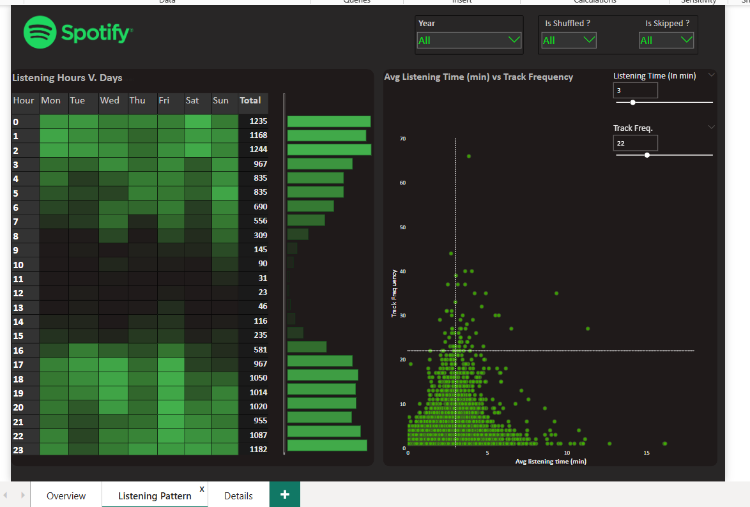

Peak Listening Hours：
- The majority of listening occurs at night (12AM-2AM）and evening hours（6PM-11PM）, especially on weekends, indicating users prefer music during their leisure or to relax.
- Faultless variable distributions in the table scatterplot above, with a focus on tabling meaningful design principles for this type of chart.
Listening Behavior Insights:
- The scatterplot tells us that most tracks are played 10-25 times with an average listen time of 2-4 minutes, showing normal track length and moderate re-listening behavior.
- The solar radio scatterplot tells us about the typical behaviour and, as such, what to set as a benchmark.
- Actually all these visualizations here were derived from data in present state, which is constantly fluctuating like flux.
User Segmentation Potential:
- Streaming features like Shuffle, Skipped, and range options for both time and degree of listening can be used to divide listener types based on their behavior patterns.
- These can be quite helpful if you're recommending people stuff, or designing features.
- Otherwise why not use them yourself?
- DETAILS GRID:
In this report, we aim to analyze Spotify data by creating an interactive and dynamic Grid View. The Grid will display key details such as Album Name, Artist Name, Track Name, and other relevant attributes.
Key Requirements:
1. Grid View with Essential Fields:
  - The Grid should present critical data points for an intuitive and structured view.
2. Drill Through Functionality:
  - Users should be able to drill through from the main reports to explore underlying data for detailed insights.
  - The drilled-through data should be exportable to a CSV file based on user requirements.
3. Drill Down, Drill Up, and Hierarchy:
  - The Grid should support hierarchical navigation, allowing users to drill down and up for in-depth data exploration.
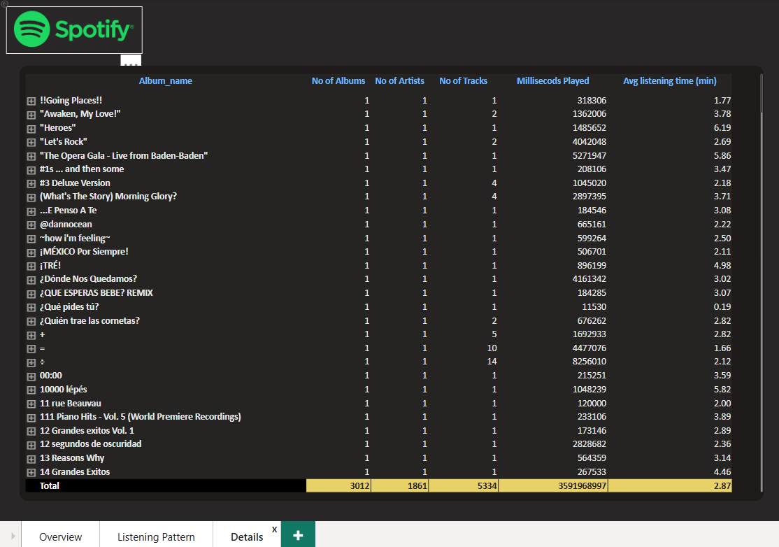

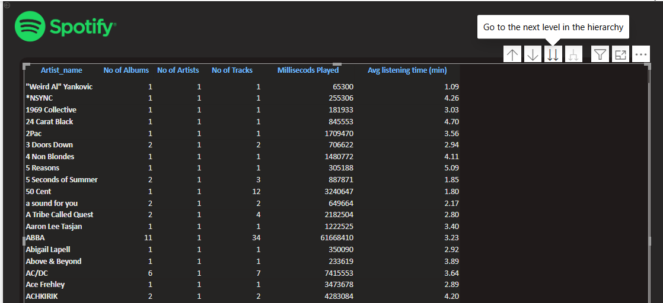

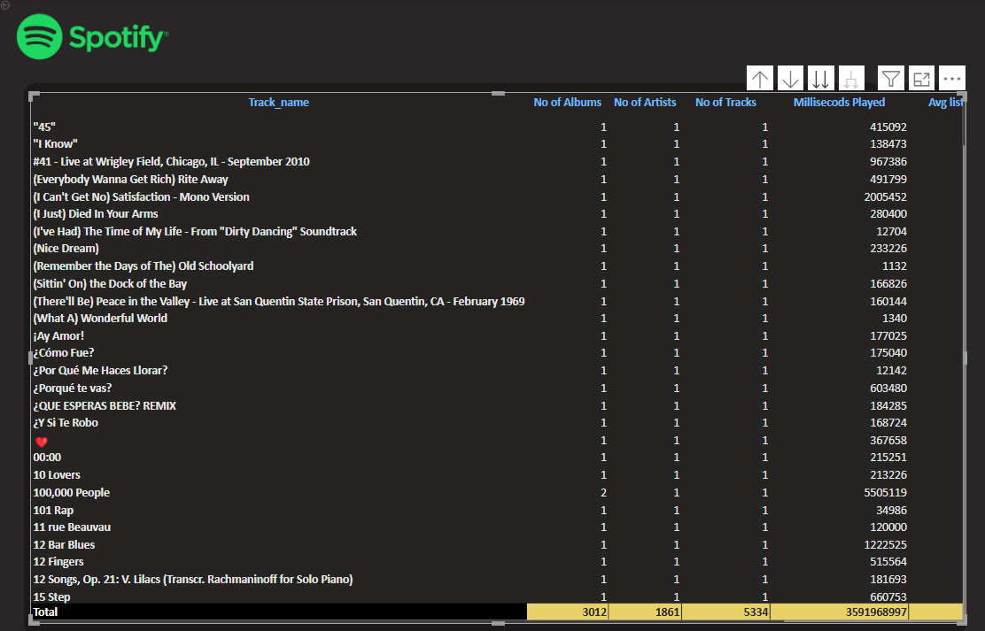
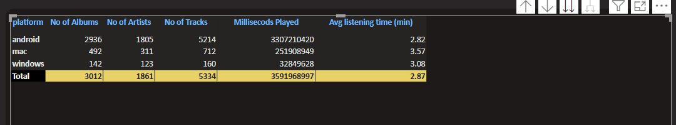

Comprehensive data grid:
- Provides detailed information for each album. This includes:
- Album name, number of artists, number of tracks, milliseconds played, and average listening time.
- It helps spot highly played or less-engaged albums through things like the number of tracks on them or how long they are set to play.

Drill Through & Export Features:
- Users can click on main dashboards into specific albums or artists for deeper insight.
- Data can be exported to CSV, useful for other external analysis or reporting.
Hierarchical Navigation:
- Drill down, drill up and album - track - artist hierarchies are built-in.
- Useful for spotting patterns like which albums with fewer tracks still get high listening time.

# Key Insights from Spotify Dashboards:
- Compared with 2023, in 2024 the number of albums played dropped by 21.82%--showing that interest in complete-albums waning.
- Listening is more concentrated at weekends, about 59% coming on this count. This implies users waiting to get into their free time are waiting there all week long.
- Most listening took place from early evening through late night, with a peak happening around 6 PM to 2 AM.
- The Beatles prove an evergreen artist and album for us—most played, suggestive of listener affection as much as taste in classic songs!
- On average a track is listened to for 2 minutes, repeated about 10 or 25 times--so there is always some time in there for emphasis and also detail.

